# Homework: SASS, CSS Transitions, Jekyll

This document defines homework assignments from the [“Web Fundamentals (HTML & CSS)“ Course @ SoftUni](https://softuni.bg/courses/web-fundamentals/). Please submit as homework a single zip / 7z archive holding the source code of all below described problems.

## Gradient City

Create a Web page like the picture below (**100% accuracy is required**). You are given the **HTML file.** Use **SASS** to achieve the desired results. Use **mixins** for the gradients. Use variables to implement colors. Implement hover effect for the menu. Making the site responsive is **optional**.

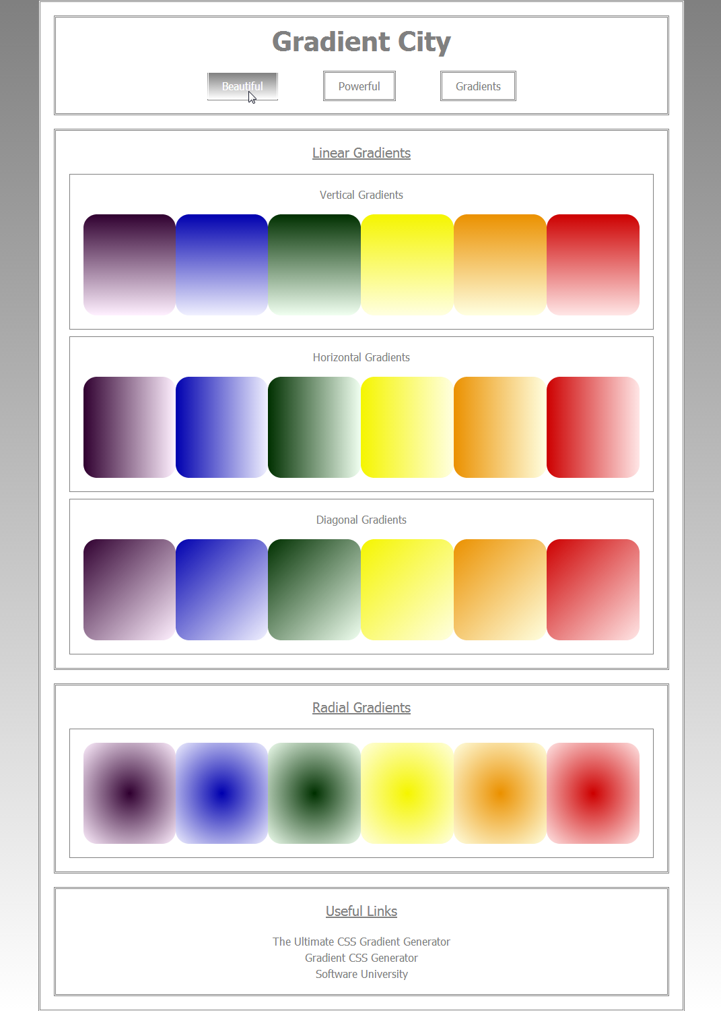

## Crazy Shaky Gallery

Using **CSS animations** create a Web page like the picture below (**100% accuracy is NOT required**).

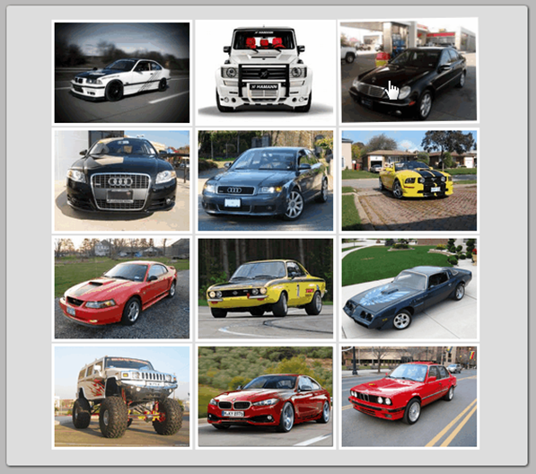 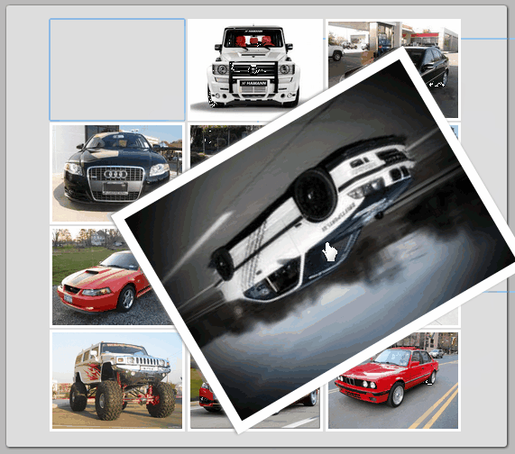

Constrains: Use **CSS3 animation and transitions** to achieve the desired results (on mouse focus and mouse hover). Do not use the same pictures and colors. The animations and transitions must be exactly the same as in the **GIF** file **02-CrazyShakyGallery** (open the GIF file with a browser to view the animations and transitions).

## Jekyll Website

Create a Web site using **Jekyll (similar to the image below)**. Install all you need and choose the theme, **different** from the one in the example. Learn how to add post and write **at least two posts**. Add also a few pages.



Hint: Windows users, use this Jekyll installation tutorial: <https://github.com/juthilo/run-jekyll-on-windows/>.

Hint: You may skip the installation of Pygments to save some pain. If you use Pigments, not that Pygments version for Jekyll should be exactly: 0.5.0.

## *Ticking Clock

Create a Web page like the picture below (**100% accuracy is NOT required**).

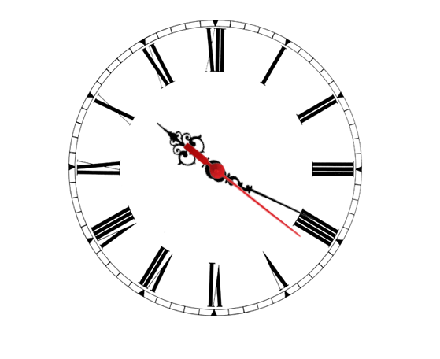

Constrains: Use **CSS3 transitions** and **JavaScript**. Rotate the arrows with CSS rotation. You may use a static image-based clock face.